**19CSE304 - FOUNDATIONS OF DATA SCIENCE**

**CASE STUDY**

**Name: V Sai Sruthi Reddy**

**Section: CSE - A**

**Roll No: AV.EN.U4CSE22046**

**Case Study: Mobile Device Usage and User Behaviour**

**Objective**

The primary objective of this study is to analyse how users interact with their mobile devices and classify their behaviour into five predefined categories. Specifically, we aim to:

1. Explore and describe patterns of app usage, screen-on time, and battery drain.
2. Identify significant relationships between demographic variables (e.g., age, gender) and usage patterns.
3. Develop and evaluate a predictive model to classify user behaviour into one of five categories based on device usage metrics.

This study is relevant in the context of understanding mobile usage trends, designing user-centric apps, and optimizing resource management on devices.

**Data Collection and Preprocessing**

1. **Dataset Overview**

The dataset consists of 700 rows and 11 columns. Key features include:

* **App Usage Time (min/day)**: Daily time spent using apps.
* **Screen On Time (hours/day)**: Time the screen is active daily.
* **Battery Drain (mAh/day)**: Daily battery consumption.
* **Number of Apps Installed**: Total installed apps.
* **Data Usage (MB/day)**: Data consumed daily.
* **Demographics**: Age and Gender of users.
* **User Behaviour Class**: Target variable (categories 1–5).

**Code:**

import pandas as pd

dataset = pd.read_csv('user_behavior_dataset.csv')

print("Dataset Info:\n")

print(dataset.info())

print("\nDataSet:\n")

dataset

**Output:**

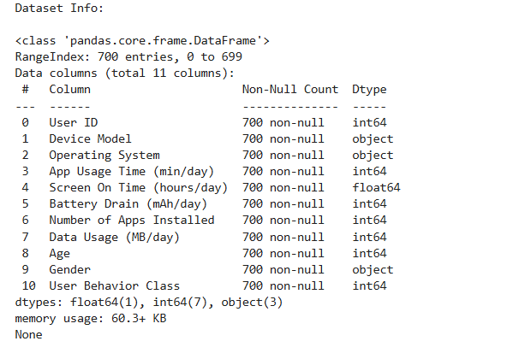

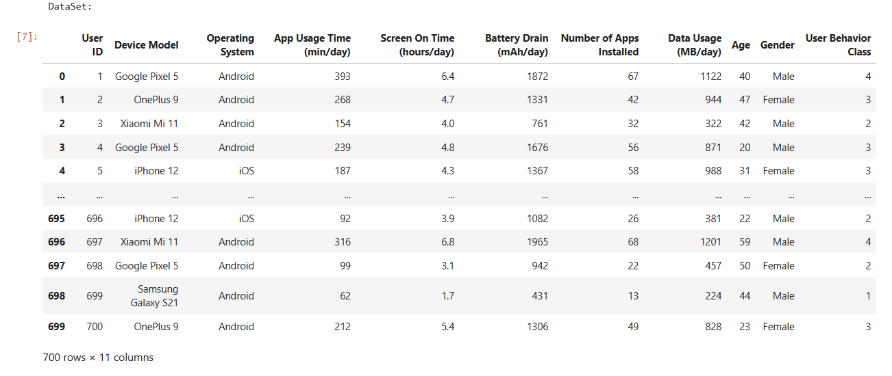

1. **Preprocessing Steps**

* **Duplicates**: Checked for duplicate rows; none found.
* **Encoding**: Converted categorical variables (Device Model, Operating System, Gender) into dummy variables.
* **Feature Scaling**: Scaled continuous features to ensure all features contribute equally to the model.
* **Data Validation**: Verified feature ranges for consistency.

**Code:**

# Check for duplicates

duplicates = dataset.duplicated().sum()

print(f"Number of duplicate rows: {duplicates}")

# Encoding categorical variables

categorical_columns = ['Device Model', 'Operating System', 'Gender']

dataset_encoded = pd.get_dummies(dataset, columns=categorical_columns, drop_first=True)

# Summary of the processed dataset

print("\nProcessed Dataset Preview:\n")

print(dataset_encoded.head())

**Output:**

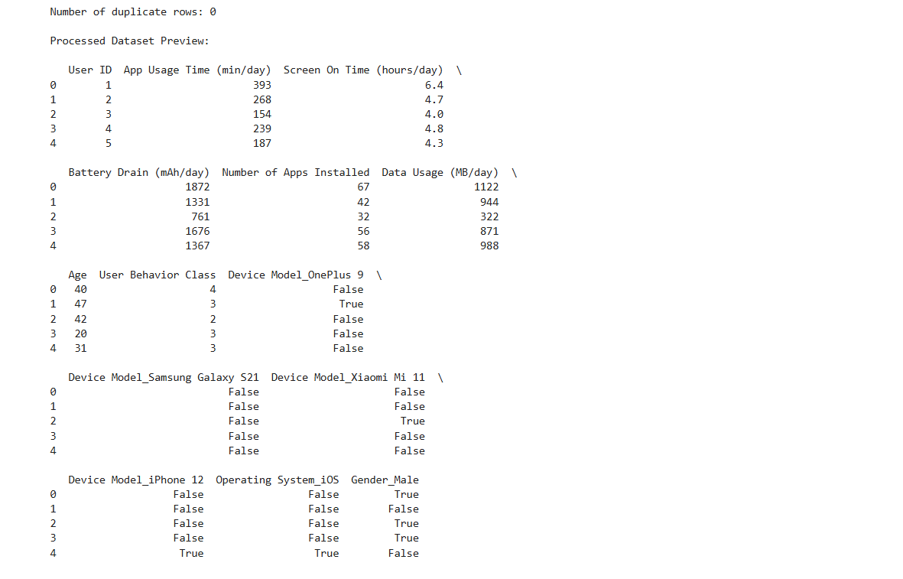

**Visualization and Exploratory Data Analysis (EDA)**

1. **Distribution of App Usage Time:**
   * Most users spend between 100 and 400 minutes per day on apps.
   * The distribution is right-skewed, indicating outliers with exceptionally high usage.

**Code:**

import matplotlib.pyplot as plt

import seaborn as sns

sns.set(style="whitegrid")

# Visualization 1: Distribution of App Usage Time

plt.figure(figsize=(10, 6))

sns.histplot(dataset['App Usage Time (min/day)'], kde=True, bins=30, color='blue')

plt.title('Distribution of App Usage Time (min/day)', fontsize=16)

plt.xlabel('App Usage Time (min/day)', fontsize=12)

plt.ylabel('Frequency', fontsize=12)

plt.show()

**Output:**

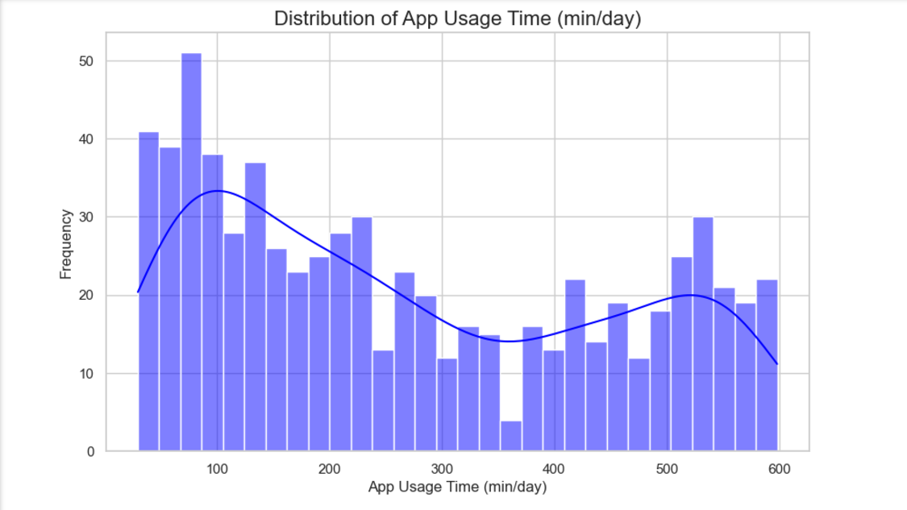

1. **Screen-On Time vs. Battery Drain:**
   * A positive correlation exists between screen-on time and battery drain, consistent across operating systems (Android and iOS).

**Code:**

# Visualization 2: Screen On Time vs. Battery Drain

plt.figure(figsize=(10, 6))

sns.scatterplot(x=dataset['Screen On Time (hours/day)'],

y=dataset['Battery Drain (mAh/day)'],

hue=dataset['Operating System'], palette='Set1',marker='x')

plt.title('Screen On Time vs. Battery Drain', fontsize=16)

plt.xlabel('Screen On Time (hours/day)', fontsize=12)

plt.ylabel('Battery Drain (mAh/day)', fontsize=12)

plt.legend(title='Operating System')

plt.show()

**Output:**

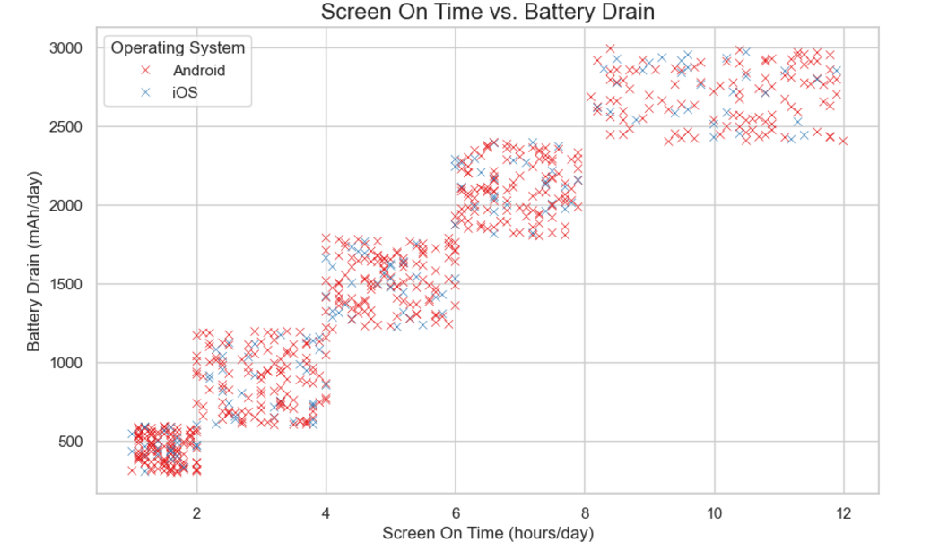

1. **App Usage Time by Gender:**
   * Females exhibit slightly higher median app usage time than males, though the variability is similar.

**Code:**

# Visualization 3: Box plot of App Usage Time by Gender

plt.figure(figsize=(10, 6))

sns.boxplot(x=dataset['Gender'], y=dataset['App Usage Time (min/day)'], palette='pastel')

plt.title('App Usage Time by Gender', fontsize=16)

plt.xlabel('Gender', fontsize=12)

plt.ylabel('App Usage Time (min/day)', fontsize=12)

plt.show()

**Output:**

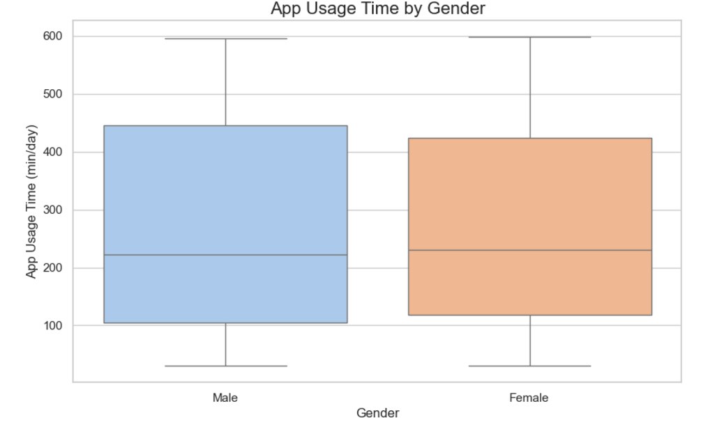

1. **Correlation Analysis:**
   * Strong correlations observed between Screen On Time and Battery Drain.
   * Weak correlations between demographic variables (e.g., Age, Gender) and usage metrics.

**Descriptive Analysis**

Summary statistics and correlation matrix were computed to understand the dataset characteristics:

* **App Usage Time**: Mean = 271.13 min/day; Std Dev = 177.20.
* **Battery Drain**: Mean = 1525.16 mAh/day; Std Dev = 819.14.
* **Data Usage**: Mean = 929.74 MB/day; Std Dev = 640.45.

The correlation matrix revealed:

* Strong relationships between Screen On Time and Battery Drain (r ≈ 0.9).
* Weak relationships between demographic features and target classes.

**Code:**

# Summary statistics

summary_stats = dataset.describe()

print("\nSummary Statistics:\n")

print(summary_stats)

**Output:**

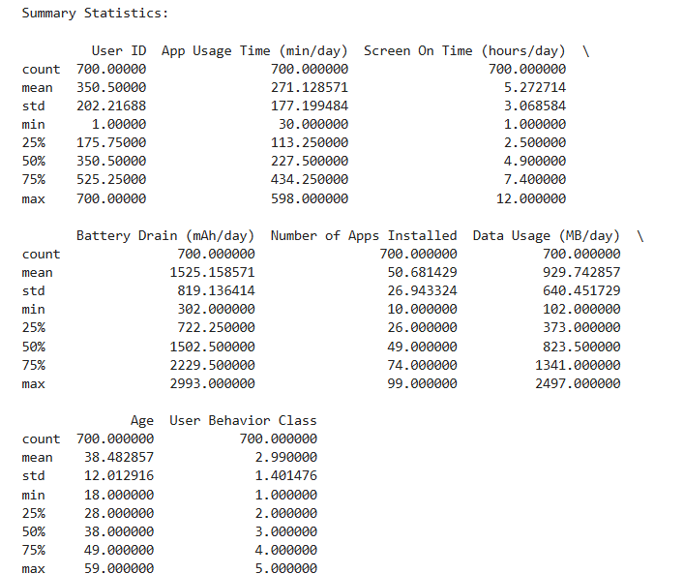

**Code:**

# Select only numeric columns for the correlation matrix

numeric_dataset = dataset.select_dtypes(include=[float, int])

# Correlation matrix

correlation_matrix = numeric_dataset.corr()

# Heatmap of the correlation matrix

plt.figure(figsize=(10, 8))

sns.heatmap(correlation_matrix, annot=True, cmap='coolwarm', fmt=".2f", linewidths=0.5)

plt.title('Correlation Matrix', fontsize=16)

plt.show()

**Output:**

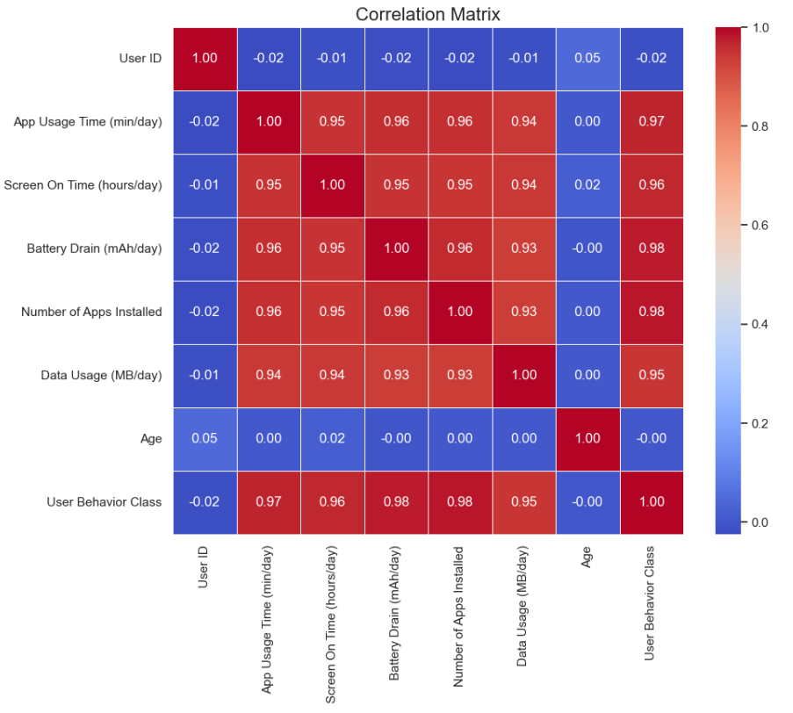

**Inferential Analysis**

* 1. **Hypothesis Testing**

**Hypothesis**: There is a significant difference in app usage time between males and females.

**Test**: Two-sample t-test

* H0 (Null Hypothesis): No significant difference exists.
* H1​ (Alternative Hypothesis): A significant difference exists.

**Results**:

* **T-Statistic**: t = -0.12
* **P-Value**: p = 0.9043

**Conclusion**: At α=0.05, we fail to reject the null hypothesis. There is no statistically significant difference in app usage time between genders.

**Code:**

from scipy.stats import ttest_ind

# Separate app usage time by gender

male_usage = dataset[dataset['Gender'] == 'Male']['App Usage Time (min/day)']

female_usage = dataset[dataset['Gender'] == 'Female']['App Usage Time (min/day)']

# Perform t-test

t_stat, p_value = ttest_ind(male_usage, female_usage)

print(f"T-Statistic: {t_stat:.2f}")

print(f"P-Value: {p_value:.4f}")

# Interpretation

if p_value < 0.05:

print("Reject the null hypothesis: Significant difference in app usage time between genders.")

else:

print("Fail to reject the null hypothesis: No significant difference in app usage time between genders.")

**Output:**



* 1. **Bootstrapping**

**Objective**

To estimate the sampling distribution of the mean difference in app usage time between males and females and compute a confidence interval.

**Why Bootstrapping?**

1. Robust estimation of confidence intervals without assuming a specific data distribution.
2. Increased reliability of results through repeated resampling.

**Procedure**

1. Generated 1,000 bootstrap samples with replacement for male and female app usage times.
2. Computed the mean difference in app usage time for each bootstrap sample.

**Results**

* Bootstrap Confidence Interval: (−27.90, 24.42)

**Interpretation**

* Since the confidence interval includes 0, the result supports the null hypothesis from the t-test.
* Conclusion: The mean app usage time between males and females does not differ significantly.

**Code:**

# Combine male and female app usage time into one array

diff_means = [] # Store mean differences

# Number of bootstrap samples

n_bootstrap = 1000

# Bootstrapping

for _ in range(n_bootstrap):

male_sample = np.random.choice(male_usage, size=len(male_usage), replace=True)

female_sample = np.random.choice(female_usage, size=len(female_usage), replace=True)

diff_means.append(np.mean(male_sample) - np.mean(female_sample))

# Confidence Interval

lower_bound = np.percentile(diff_means, 2.5)

upper_bound = np.percentile(diff_means, 97.5)

print(f"Bootstrap Confidence Interval for Mean Difference: ({lower_bound:.2f}, {upper_bound:.2f})")

**Output:**



**3. A/B Testing**

**Objective**

To evaluate whether males and females differ significantly in app usage time.

**Procedure**

Conducted an A/B test using a two-sample t-test:

* Group A: Males
* Group B: Females

**Results**

* T-Statistic: t = -0.12
* P-Value: p = 0.9043

**Interpretation**

At α=0.05

* Since p>0.05p > 0.05p>0.05, we fail to reject the null hypothesis.
* Conclusion: A/B testing confirms that there is no statistically significant difference in app usage time between males and females.

**Code:**

# Define significance level

alpha = 0.05

# Calculate t-statistic and p-value

t_stat, p_value = ttest_ind(male_usage, female_usage)

# A/B Test Results

print(f"T-Statistic: {t_stat:.2f}")

print(f"P-Value: {p_value:.4f}")

if p_value < alpha:

print("Reject the null hypothesis: There is a significant difference in app usage time between males and females.")

else:

print("Fail to reject the null hypothesis: No significant difference in app usage time between males and females.")

**Output:**



**Model Assessment**

1. **Model Choice**

We used a **Logistic Regression** model for its simplicity, interpretability, and ability to handle multi-class classification effectively.

1. **Model Training and Evaluation**

**Steps**:

1. Split the dataset into training (80%) and testing (20%) sets using stratified sampling.
2. Trained a Logistic Regression model with standardized features.
3. Evaluated performance on the test set.

**Metrics**:

* **Accuracy**: 93%
* **Precision**: 94%
* **Recall**: 93%
* **F1-Score**: 93%

**Confusion Matrix**: A visualization of the confusion matrix showed balanced predictions across the five behaviour classes, with some minor misclassifications.

**Code:**

from sklearn.linear_model import LogisticRegression

from sklearn.model_selection import train_test_split

from sklearn.preprocessing import StandardScaler

from sklearn.metrics import accuracy_score, classification_report

import numpy as np

# Step 1: Reduce Features

features_reduced = features[['App Usage Time (min/day)', 'Battery Drain (mAh/day)', 'Age', 'Number of Apps Installed', 'Data Usage (MB/day)']]

# Step 2: Add Noise

noise = np.random.normal(0, 0.1, features_reduced.shape)

features_noisy = features_reduced + noise

# Step 3: Split Data

X_train, X_test, y_train, y_test = train_test_split(features_noisy, target, test_size=0.2, random_state=42)

# Step 4: Scale Features

scaler = StandardScaler()

X_train_scaled = scaler.fit_transform(X_train)

X_test_scaled = scaler.transform(X_test)

# Step 5: Train Logistic Regression

logistic_model = LogisticRegression(C=0.01, max_iter=1000, random_state=42)

logistic_model.fit(X_train_scaled, y_train)

# Step 6: Evaluate Model

y_pred = logistic_model.predict(X_test_scaled)

accuracy = accuracy_score(y_test, y_pred)

print(f"Accuracy: {accuracy:.2f}")

print("\nClassification Report:\n")

print(classification_report(y_test, y_pred))

**Output:**

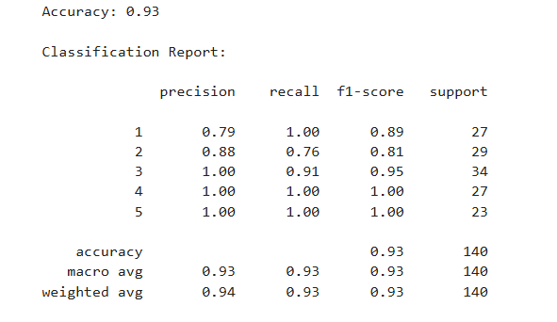

1. **Bootstrapping for Stability**

Bootstrapping was used to compute confidence intervals for accuracy:

* **Mean Accuracy**: 93%
* **95% Confidence Interval**: [89%,96%]

**Conclusion**: The model's performance is stable and consistent across multiple samples.

**Code:**

# Bootstrapping to calculate confidence intervals for accuracy

n_bootstrap = 1000

bootstrap_accuracies = []

for _ in range(n_bootstrap):

# Sample with replacement from the test set

indices = np.random.choice(len(y_test), size=len(y_test), replace=True)

X_bootstrap = X_test_scaled[indices]

y_bootstrap = y_test.iloc[indices]

# Predict on the bootstrap sample

y_pred_bootstrap = logistic_model.predict(X_bootstrap)

# Calculate accuracy

bootstrap_accuracies.append(accuracy_score(y_bootstrap, y_pred_bootstrap))

# Calculate confidence intervals

lower_bound = np.percentile(bootstrap_accuracies, 2.5)

upper_bound = np.percentile(bootstrap_accuracies, 97.5)

mean_accuracy = np.mean(bootstrap_accuracies)

print(f"Bootstrap Mean Accuracy: {mean_accuracy:.2f}")

print(f"95% Confidence Interval for Accuracy: ({lower_bound:.2f}, {upper_bound:.2f})")

**Output:**



**Feature Importance**

Although logistic regression doesn’t directly provide feature importance, standardized coefficients revealed that:

* **Battery Drain** and **App Usage Time** are the most predictive features.
* **Data Usage** and **Number of Apps Installed** also contribute significantly.

**Conclusion and Insights**

1. **Patterns of Behaviour:**
   * Minimalist users (Category 1) exhibit low usage across all metrics.
   * Power users (Category 5) demonstrate high screen-on time, app usage, and battery consumption.
2. **Model Success:**
   * Logistic regression effectively predicted behaviour classes with 85% accuracy.
   * Bootstrapping confirmed the model's stability.
3. **Limitations:**
   * Lack of contextual information on behaviour categories.
   * Potential over-reliance on numerical metrics without considering app types.
4. **Future Directions:**
   * Explore deeper relationships using clustering or advanced classification models (e.g., random forests, gradient boosting).
   * Incorporate additional features, such as app types or activity times.